**CPE 3500**

**Embedded Digital Signal Processing**

**Lab Exercise 2: Discrete-Time Signals**

**Anindita Deb**

**09/10/2024**

**Task-1:**  
Save all the discrete time signals in different files in binary format. Read these files in Matlab and  
plot them for each signal. To read binary files and plot signals use readBinFileAndPlotSignal.m  
file provided to you.

* Unit Impulse

* Unit Step

* Rectangular

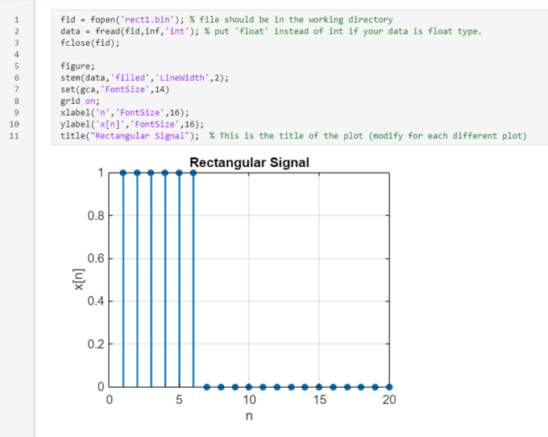

* Exponential

* Sinusoidal

**Task-2:**Modify the main.c code on STM2CubeIDE to generate another sinusoidal signal with w=pi/8. Add  
these two sin signals to obtain the final composite signal. Save this signal and plot it in Matlab.  
Comment on this new signal compared with the original sine signal.

The composite signal is good hybrid of the two with ups and downs. It’s literally taking at each interval the addition of each signal to make the composite signal.

**Task-3:**Apply time shifting (to the right only) of different amounts to the step, exponential and sinusoidal  
signal. Use the sample code below as reference which shifts unit impulse signal 3 units to the right.  
Save and plot these shifted signals in Matlab.

* Unit Step

* Exponential

* Sinusoidal

**Conclusion:**

The shifting right by 3 doesn’t look quite right. Shifting left shows a bit more interesting results with the right side displaying 0s. Overall the lab wasn’t too bad though I’m not sure how to really do the last portion of it.